Name : ARYAN MAGAR
Branch : AI(AI&DS)
Class : Second Year
Div : B
Roll No : 63
Practical No : 05
Aim : Data Visualization with Matplotlib: Data visualization on a dataset using matplotlid and seaborn libraries Theory :
1. What is the importance of data visualization in data analysis? How does visualization help in exploratory data analysis (EDA)?
Data visualization is crucial in data analysis because it transforms complex datasets into easily understandable graphical representations. This makes patterns, trends, outliers, and relationships immediately apparent, which might be difficult or impossible to discern from raw data tables or statistical summaries alone.
In Exploratory Data Analysis (EDA), visualization plays a pivotal role:
Identification of Patterns and Trends: Visualizations like line plots, scatter plots, and heatmaps quickly reveal underlying patterns, trends over time, or correlations between variables.
Detection of Outliers and Anomalies: Box plots, scatter plots, and histograms can highlight data points that deviate significantly from the rest, which might indicate errors, unusual events, or interesting phenomena.
Understanding Data Distribution: Histograms and density plots show the shape, spread, and central tendency of single variables, helping to understand if data is normally distributed, skewed, or multimodal.
Comparison Between Groups: Bar plots, box plots, and violin plots are excellent for comparing characteristics across different categories or groups. Assessment of Data Quality: Visualizing data can expose missing values, inconsistent entries, or data entry errors, guiding data cleaning efforts.
Hypothesis Generation: By visually inspecting data, analysts can form initial hypotheses about relationships and phenomena, which can then be tested with more rigorous statistical methods.
Communication of Insights: Visualizations are powerful tools for communicating findings to both technical and non-technical audiences, making insights more accessible and impactful.
2. What is the difference between Matplotlib and other visualization libraries?
Matplotlib is the foundational plotting library in Python, providing a highly flexible and comprehensive environment for creating static, interactive, and animated visualizations. It gives users a lot of control over every aspect of a plot.
Key differences and comparisons with other libraries:
Low-Level vs. High-Level: Matplotlib is generally considered a low-level library. This means you have to explicitly define many plot elements (axes, labels, titles, etc.). This offers immense customization but can be more verbose for common plots.
Seaborn: Built on top of Matplotlib, Seaborn is a high-level library that provides a more convenient and aesthetically pleasing interface for drawing statistical graphics. It simplifies the creation of complex plots, especially those involving multiple variables or statistical estimations, with fewer lines of code. Seaborn excels at visualizing relationships between variables and distributions within datasets, often with better default aesthetics than raw Matplotlib. Plotly/Bokeh: These are libraries designed for creating interactive and webbased visualizations. While Matplotlib can generate interactive plots, Plotly and Bokeh are inherently designed for dynamic, browser-embeddable plots that allow zooming, panning, and hovering for detailed information. They are often used for dashboards or web applications.
Altair: This is a declarative statistical visualization library based on Vega-Lite. It focuses on specifying what you want to plot rather than how to plot it. It's great for quickly exploring data and creating aesthetically pleasing interactive plots, but it might offer less fine-grained control than Matplotlib.
In essence, Matplotlib provides the building blocks; other libraries often use Matplotlib as their backend to offer specialized functionality, higher-level abstractions, or interactive capabilities.
3. What is the purpose of the pyplot module in Matplotlib?
pyplot is a module in Matplotlib that provides a MATLAB-like interface for plotting. It is the most commonly used module for creating plots with Matplotlib because it offers a convenient and efficient way to create figures and axes, plot data, and customize plots with simple function calls.
The purpose of pyplot is to:
Simplify Plotting: It streamlines the process of creating plots by automatically managing figures and axes. For example, plt.plot() will create a figure and an axes if none exist, and then draw on them.
Provide a State-Based Interface: It maintains the current figure and plotting area. All pyplot functions operate on the current figure and axes, simplifying the workflow for generating simple plots sequentially.
Offer Quick Plotting Functions: It includes a vast array of functions for creating various types of plots (e.g., plot for line plots, scatter for scatter plots, hist for histograms, bar for bar charts), as well as functions for adding labels, titles, legends, and customizing plot aesthetics.
Integrate with NumPy: It is designed to work seamlessly with NumPy arrays, making it ideal for scientific and numerical data visualization.
When you import matplotlib.pyplot as plt , you are essentially bringing in a set of functions that make it easy to generate plots with minimal code, acting as an interactive plotting environment.
5. Why is customization important in data visualization? What customization options are available in Matplotlib?
Importance of Customization in Data Visualization:
Customization is paramount in data visualization for several critical reasons:
- Clarity and Readability: Well-customized plots are easier to read and understand. Appropriate labels, titles, legends, and color choices prevent ambiguity and ensure that the message of the data is conveyed clearly.
- Effective Communication: Different audiences require different levels of detail and presentation styles. Customization allows tailoring a visualization to a specific audience, making complex information accessible to non-technical stakeholders or highlighting specific insights for experts.
- Highlighting Key Insights: By adjusting colors, adding annotations, emphasizing certain data points, or changing scales, you can direct the viewer's attention to the most important aspects or patterns in the data.
- Aesthetics and Professionalism: Visually appealing and professionally designed plots enhance credibility and engagement. A poorly designed or generic plot can undermine the impact of valuable data insights.
- Branding and Consistency: In a professional context, customization ensures that visualizations align with brand guidelines or maintain a consistent look and feel across reports and presentations.
- Addressing Specific Questions: Sometimes, a default plot might not fully answer a specific research question. Customization allows for the addition of reference lines, error bars, or subplots that directly address detailed inquiries.
- Overcoming Default Limitations: No single default setting can perfectly suit all datasets or analytical goals. Customization empowers the analyst to overcome the limitations of default plot settings and create truly bespoke visualizations.
Customization Options Available in Matplotlib:
Matplotlib offers an unparalleled level of control and customization over virtually every element of a plot. Here are some key customization options:
  - Figure and Axes Properties:
Figure Size: plt.figure(figsize=(width, height)) to control the overall dimensions of the plot.
Subplots: plt.subplot(nrows, ncols, index) or
fig.add_subplot() for arranging multiple plots in a single figure. Axis Limits: plt.xlim() , plt.ylim() to set the minimum and maximum values for the x and y axes.
Axis Scales: plt.xscale() , plt.yscale() for linear, log, symlog, or logit scales.
  - Plot Elements (Lines, Markers, Bars, etc.):
Colors: color='red' , c='blue' for plot elements.
Line Styles: linestyle='--' , ls=':' for dashed, dotted, etc.
Line Width: linewidth=2 , lw=1.5 .
Markers: marker='o' , marker='s' for circle, square, etc.
Marker Size/Color/Edge: markersize , markeredgecolor , markerfacecolor .
Transparency (Alpha): alpha=0.5 for plot elements.
  - Labels, Titles, and Legends:
Title: plt.title('My Plot Title') .
Axis Labels: plt.xlabel('X-axis Name') , plt.ylabel('Y-axis Name') .
Tick Labels: plt.xticks() , plt.yticks() for setting tick locations and labels, and rotating them.
Legend: plt.legend() to identify different plot series, with options for location, font size, and frame.
Text Annotations: plt.text() , plt.annotate() for adding custom text or arrows to specific points on the plot.
  - Grids and Background:
Grids: plt.grid(True) to add a grid, with options for linestyle , color , and alpha .
Background Color: Can be set on the figure or axes using properties like facecolor .
  - Text and Fonts:
Font Properties: Control font family, size, weight, and style for all text elements using matplotlib.rcParams or directly in text functions.
  - Colormaps:
For plots like heatmaps or scatter plots with a third variable, cmap arguments allow choosing from various perceptual colormaps (e.g.,
'viridis' , 'plasma' , 'coolwarm' ).
  - Saving Plots:
plt.savefig('my_plot.png', dpi=300,
bbox_inches='tight') to save plots in various formats (PNG, JPG, PDF, SVG) with control over resolution and layout.
  - Stylesheets:
Matplotlib provides pre-defined stylesheets
( plt.style.use('ggplot') , 'seaborn-v0_8' ) that quickly change the aesthetic defaults of plots, making them more visually appealing or consistent with common design practices.
 4. Explain the process of creating a basic line plot.
Creating a basic line plot with Matplotlib's
pyplot
module typically involves these
steps:
1
.
Import
pyplot
:
Start by importing the
pyplot
module, usually aliased as
plt
for convenience.
import
matplotlib.pyplot
as
plt
2. Prepare Data: Define the data you want to plot. A line plot typically requires two arrays or lists of numerical values: one for the x-axis and one for the y-axis.

function takes your x and y data as arguments.
plt.plot(x, y)
4. Add Labels and Title (Optional but Recommended): Make your plot informative by adding an x-axis label, a y-axis label, and a title. This helps viewers understand what the plot represents.
x = [
1
,
2
,
3
,
4
,
5
]
y = [
2
,
4
,
1
,
5
,
3
]
3
.
Create the Plot:
Use the
plt.plot()
function to generate the line plot. This
You can also customize aspects like line color, style, and markers by passing
additional arguments to
plt.plot()
(e.g.,
plt.plot(x, y, color='red',
linestyle='--', marker='o')
).
import
pandas
as
pd
import
numpy
as
np
import
matplotlib.pyplot
as
plt
import
seaborn
as
sns
plt.xlabel(
'X-axis Label'
)
plt.ylabel(
'Y-axis Label'
)
plt.title(
'My Basic Line Plot'
)
5
.
Display the Plot:
Finally, use
plt.show()
to display the plot. This command
renders the plot window.
plt.show()
Full Example:
import
matplotlib.pyplot
as
plt
x = [
1
,
2
,
3
,
4
,
5
]
y = [
2
,
4
,
1
,
5
,
3
]
plt.plot(x, y)
plt.xlabel(
'Numbers'
)
plt.ylabel(
'Values'
)
plt.title(
'Simple Line Plot Example'
)
plt.grid(
True
)

# Optional: add a grid
plt.show()
Feature1
Feature2
Category
Value
Date
0
37.454012
21.571459
D
37.298094
2023-01-01
1
95.071431
51.820521
D
27.277292
2023-01-02
2
73.199394
35.717799
C
43.302276
2023-01-03
3
59.865848
45.428535
A
62.845982
2023-01-04
4
15.601864
65.378324
D
53.211406
2023-01-05
# Set default style for seaborn plots
sns.set_style
(
"whitegrid"
)
# Create a sample dataset for demonstration
np.random.seed
(
42
)

# for reproducibility
data =
{

'Feature1'
:
np.random.rand
(
100
)
*
100
,

'Feature2'
:
np.random.rand
(
100
)
*
50
+
20
,

'Category'
:
np.random.choice
([
'A'
,

'B'
,

'C'
,

'D'
]
,

100
)
,

'Value'
:
np.random.normal
(
loc=
50
,
scale=
15
,
size=
100
)
,

'Date'
:
pd.date_range
(
start=
'2023-01-01'
,
periods=
100
,
freq=
'D'
)
}
df = pd.DataFrame
(
data
)
display
(
df.head
())
 Scatter Plot
A scatter plot displays values for two variables as points. It helps in visualizing the relationship or correlation between two numerical variables.
plt.figure
(
figsize=
(
8
,

6
))
sns.scatterplot
(
x=
'Feature1'
,
y=
'Feature2'
,
hue=
'Category'
,
data=df
,
s
plt.title
(
'Scatter Plot of Feature1 vs. Feature2 by Category
'
)
plt.xlabel
(
'Feature1'
)
plt.ylabel
(
'Feature2'
)
plt.legend
(
title=
'Category'
)
plt.grid
(
True
)
plt.show
()
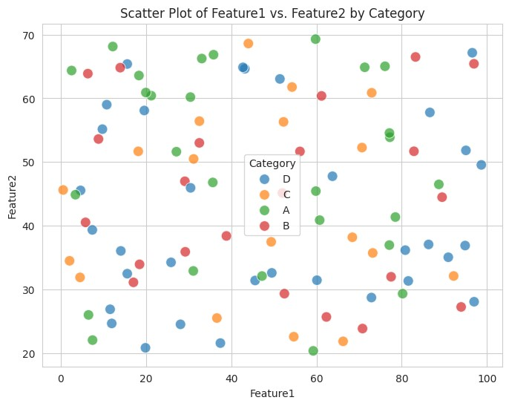
Line Plot

A line plot is used to display data points connected by straight line segments. It is commonly used to visualize trends over time or across an ordered category.
# To show a clear trend, let's group by date and s
um 'Value'
df_daily_sum = df.groupby
(
'Date'
)[
'Value'
]
.
sum
()
.reset_index
()
plt.figure
(
figsize=
(
12
,

6
))
sns.lineplot
(
x=
'Date'
,
y=
'Value'
,
data=df_daily_sum
)
plt.title
(
'Line Plot of Daily Sum of Value Over Time'
)
plt.xlabel
(
'Date'
)
plt.ylabel
(
'Sum of Value'
)
plt.xticks
(
rotation=
45
)
plt.grid
(
True
)
plt.show
()
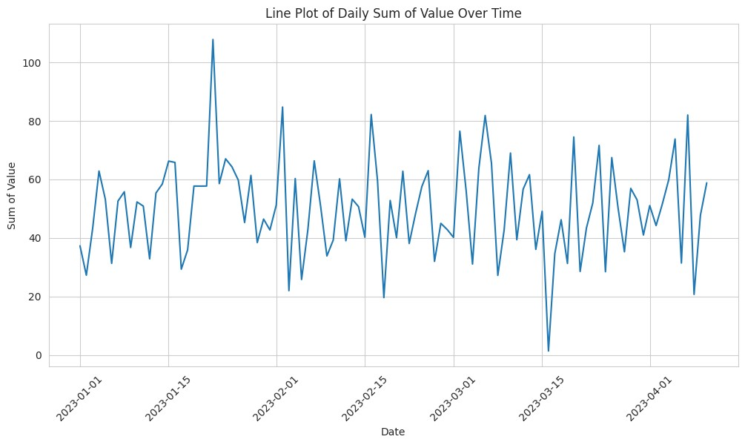
Bar Plot

A bar plot presents categorical data with rectangular bars with heights or lengths proportional to the values that they represent. Bar plots are used for comparing quantities of different categories.
# Calculate the mean 'Value' for each 'Category'
df_category_mean = df.groupby
(
'Category'
)[
'Value'
]
.mean
()
.reset_index
(
plt.figure
(
figsize=
(
8
,

6
))
sns.barplot
(
x=
'Category'
,
y=
'Value'
,
hue=
'Category'
,
data=df_category_
plt.title
(
'Bar Plot of Average Value by Category'
)
plt.xlabel
(
'Category'
)
plt.ylabel
(
'Average Value'
)
plt.show
()
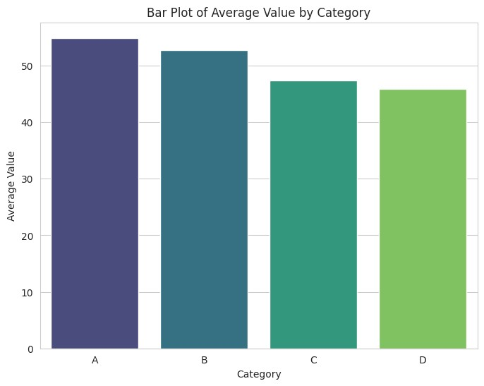
Histogram

A histogram is an accurate graphical representation of the distribution of numerical data. It is an estimate of the probability distribution of a continuous variable.
plt.figure
(
figsize=
(
8
,

6
))
sns.histplot
(
df
[
'Value'
]
,
bins=
15
,
kde=
True
,
color=
'skyblue'
)
plt.title
(
'Histogram of Value Distribution'
)
plt.xlabel
(
'Value'
)
plt.ylabel
(
'Frequency'
)
plt.show
()
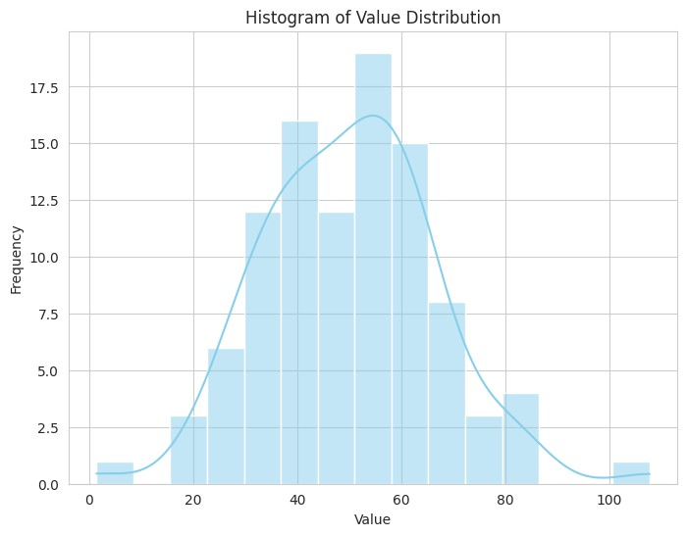
Box Plot

A box plot (or box-and-whisker plot) displays the distribution of a dataset based on a five-number summary: minimum, first quartile (Q1), median, third quartile (Q3), and maximum. It can also identify outliers.
plt.figure
(
figsize=
(
8
,

6
))
sns.boxplot
(
x=
'Category'
,
y=
'Value'
,
hue=
'Category'
,
data=df
,
palette=
plt.title
(
'Box Plot of Value Distribution by Category'
)
plt.xlabel
(
'Category'
)
plt.ylabel
(
'Value'
)
plt.show
()
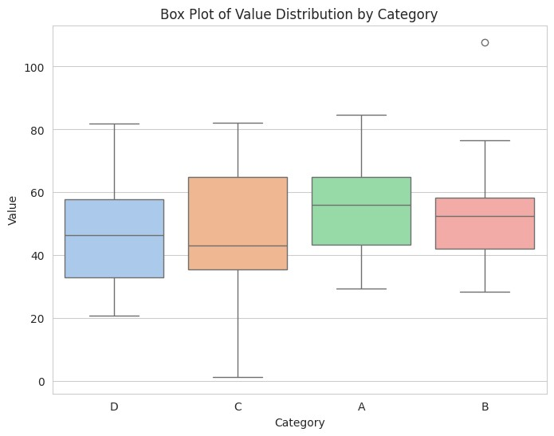
Pair Plot

A pair plot (or scatterplot matrix) creates a grid of scatter plots for each pair of variables in a dataset. It is useful for visualizing relationships between multiple numerical variables and distributions of individual variables.
sns.pairplot
(
df
,
hue=
'Category'
,
vars=
[
'Feature1'
,

'Feature2'
,

'Value
plt.suptitle
(
'Pair Plot of Numerical Features by Category'
,
y=
1.02
)

#
plt.show
()

